Roger Kreitman: Friday, 06 December 2013

Project status: “Incoterms Explained” website

Home page

Decisions about the banner – both design questions and content questions – action with RAK

The three panels – design and wording issues – RAK has provided new wording and various alternatives for the colour scheme/rollover – see most recent exchange of emails

United States perspective – words to be removed

Still issues with the tabbed forms “Want to learn more”. RAK has documented these

Bottom navigation area – typo “About Mantissa”



“The Incoterms Rules” section

I have given guidance on size of the headings for the right-hand panel (equivalent to 22 pixels in Adobe Garamond Pro)

Specific pages

RAK comments about “The logic of the Incoterms 2010 rules”,
Page 7 of latest document

The following two issues not dealt with:

The logic of the rules

Is there a way of giving me a border for this table, and/or a vertical rule between the two columns?

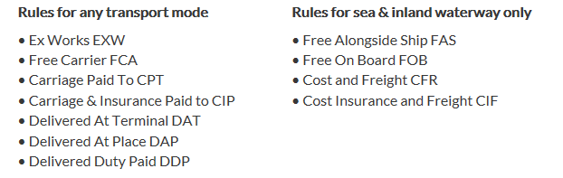

Missing space – pays for transport

